RESEARCH OPPORTUNITIES IN CLOUD INTEROPERABILITY AND PORTABILITY – DEVELOPMENT OF A FRAMEWORK
B. Priya¹, Kamala B², J.M. Nandhini ³, T S Gughan ⁴
1 Department of Computer Science and Engineering, Sri Sairam Engineering College, Chennai
bpriya.cse@sairam.edu.in
2 Department of Information Technology, Sri Sairam Engineering College, Chennai
kamala.it@sairam.edu.in
3 Department of Information Technology, Sri Sai Ram Institute of Technology, Chennai
nandhini.it@sairamit.edu.in
4 Department of Computer Science and Engineering, Vellore Institute of Technology, Chennai
tsgughan18@gmail.com

Abstract
The cloud services ecosystem has been a critical area of research and development globally. With the rapid adoption of cloud computing, organizations across sectors are leveraging cloud services to improve operational efficiency, scalability, and cost-effectiveness. Interoperability is the ability of two cloud environments that are distinct to exchange information in a way that both can understand. Cloud portability is the capacity to move data and applications from one cloud environment to another with minimal disruption. This paper deals with the review to enhance cloud interoperability and portability across various cloud platforms. This involves developing and validating a framework and tools that address the current challenges in cloud computing, such as standardization gaps, vendor lock-in, and efficient resource allocation during application migration. This review paper aims to contribute to the development of cloud-agnostic solutions, ensuring seamless integration and migration of services and data across different cloud environments. Furthermore, this paper presents a practical implementation case study demonstrating the migration of a Kubernetes application from Amazon Elastic Kubernetes Service (AWS EKS) to a local bare-metal cluster using Velero. This real-world execution highlights the dynamic telemetry of the migration process and exposes practical vendor lock-in challenges, such as cloud-specific load balancer bindings and private container registry authentication, proposing actionable workarounds to achieve true portability.
Keywords:
Cloud Ecosystem, Interoperability, Portability, CSD, Cloud Framework
1. INTRODUCTION
As cloud computing becomes increasingly integral to the digital infrastructure, the absence of comprehensive, localized standards presents significant challenges, particularly in ensuring interoperability, data security, and regulatory compliance. This study seeks to address these issues by mapping the landscape and providing targeted recommendations for standard development. Key players such as AWS, Microsoft Azure, and Google Cloud dominate the global market.
The recent literature in cloud interoperability and portability presents a comprehensive view of the ongoing advancements and challenges in this field, emphasizing the need for standardization, the exploration of use cases, and the integration of diverse services in cloud environments.

1.1 Need for the Study
The significance of this research lies in its potential to transform the Cloud computing sector by fostering a more standardized, secure, and interoperable environment. By bridging the gaps in current standards, the research will not only enhance the operational efficiency and reliability of cloud service providers but also instill greater confidence among users and stakeholders. Despite significant progress, challenges persist, particularly in the areas of data security, privacy, and regulatory compliance. Some of the key areas that are needed to be addressed are:

- Industry Challenges: The cloud computing industry faces significant challenges in interoperability and portability, impacting service flexibility and efficiency. Use-case testing provides practical insights into these challenges.
- Reducing Dependency: Reducing dependency on single cloud service providers and mitigating risks associated with vendor lock-in, as demonstrated through various use-case scenarios.
- Legal and Regulatory Compliance: Ensuring cloud services comply with evolving legal and regulatory standards, particularly in data protection and privacy, with use-case testing to explore different compliance scenarios.
- Advancing Cloud Technology: Contributing to the advancement of cloud technology by addressing current limitations and setting the stage for future innovations, backed by real-world use-case testing.

The global context of cloud computing reveals a landscape where the adoption and integration of cloud services have been accompanied by a concerted effort to establish comprehensive standards and best practices. These efforts are critical for addressing the complexities of cloud computing, particularly in terms of security, interoperability, and regulatory compliance.

1.2 Specific Objectives of Investigation
To effectively address the identified gaps Cloud service standards, this review paper will explore key questions as below, focused on improving interoperability, data security, regulatory compliance and scalability.
- Developing Standardization Frameworks: To propose a set of standards or models for cloud service descriptions that enhances interoperability and portability.
- Overcoming Vendor Lock-in: To explore and develop cloud-agnostic tools and methodologies that mitigates the challenges of vendor lock-in.
- Optimizing Resource Allocation: To investigate and propose techniques for efficient resource allocation during cloud application migration.
- Assessing Legal and Regulatory Impact: To analyze the impact of legal and regulatory frameworks on cloud services, focusing on data protection and privacy.
- Middleware Solution Development: To design and test middleware solutions that facilitate application portability across different cloud services.
- Hybrid/Multi-Cloud Environment Management: To explore strategies for effective orchestration and management of hybrid or multi-cloud environments.
2. LITERATURE REVIEW
Globally, the significance of cloud computing has driven organizations and governments to prioritize the development of standards that can guide the secure and efficient use of cloud technologies. The ISO/IEC 27001 standard for information security management, along with its cloud-specific counterparts such as ISO/IEC 27017 and ISO/IEC 27018, has been widely adopted as a benchmark for ensuring the confidentiality, integrity, and availability of data in the cloud. These standards provide a robust framework that organizations can use to safeguard their cloud environments, thereby enhancing trust among users and stakeholders.
In the United States, the National Institute of Standards and Technology (NIST) has played a pivotal role in shaping cloud computing standards. NIST's Cloud Computing Framework provides a comprehensive set of guidelines that address key issues such as cloud security, data management, and service interoperability. The framework is widely regarded as a reference model for both public and private sector organizations seeking to implement cloud solutions in a secure and compliant manner. NIST's work underscores the importance of a structured approach to cloud adoption, particularly in a diverse and complex market like the United States, where regulatory requirements can vary significantly across states and industries.
Europe has also been at the forefront of cloud standardization efforts, driven by the need to harmonize regulations across the European Union. The General Data Protection Regulation (GDPR) is a prime example of how cloud standards have been integrated into broader data protection laws. GDPR mandates strict guidelines for data privacy and security, including how cloud services handle personal data. This has prompted cloud service providers to adopt stringent measures to comply with GDPR, setting a high standard for data protection that has influenced cloud practices globally. Additionally, the European Union Agency for Cybersecurity (ENISA) has developed guidelines for cloud security, further contributing to the establishment of a secure cloud environment across Europe.
In Asia, countries like Japan and South Korea have also recognized the need for cloud standards, particularly in response to the rapid digitalization of their economies. Japan's Ministry of Economy, Trade, and Industry (METI) has issued guidelines for cloud service providers, focusing on areas such as data sovereignty and service continuity. These guidelines are part of a broader strategy to ensure that Japan's critical infrastructure is protected as it increasingly relies on cloud computing. Similarly, South Korea has implemented regulations that require cloud service providers to adhere to specific security and data management standards, reflecting the country's emphasis on protecting its digital infrastructure.
The global financial industry has also been proactive in developing cloud standards, recognizing the sector's unique security and regulatory requirements. The Financial Stability Board (FSB) and the Basel Committee on Banking Supervision (BCBS) have both issued guidelines that address the use of cloud computing in financial services. These guidelines emphasize the need for robust risk management practices, including due diligence when selecting cloud service providers and ensuring compliance with regulatory requirements. The financial industry's approach to cloud standardization serves as a model for other sectors that require a high level of security and regulatory oversight.
Deshmukh et al. [1] provide a forward-looking perspective on the role of cloud computing in e-governance and digital innovation. Their analysis reinforces the idea that, for India to sustain its momentum in digital transformation, there must be a concerted effort to establish and enforce cloud standards that address the unique challenges faced by the country. Such standards are crucial for ensuring that the benefits of cloud computing are fully realized, particularly in terms of improving public services and fostering innovation in the private sector.
Zehra et al. [2] expand the discussion by exploring the broader implications of cloud computing in the context of Digital India 2.0, focusing on areas like artificial intelligence and aviation. As these sectors increasingly rely on cloud technologies, the lack of standardized practices becomes more pronounced. The development of sector-specific standards would ensure that emerging technologies are seamlessly integrated into the cloud ecosystem, enhancing innovation while maintaining high levels of security and efficiency.
Sharma et al. [3] take a systems approach to cloud adoption, highlighting the inter connectedness of technological, organizational, and environmental factors. Their work illustrates the complexities involved in scaling cloud adoption across an entire nation, particularly in an emerging economy like India. The diversity of India's industrial landscape demands standards that can accommodate various levels of technological maturity while ensuring that cloud services are accessible, secure, and interoperable across different sectors. Without such standards, the potential for widespread adoption of cloud technologies remains constrained, limiting the benefits that these technologies could bring to the economy as a whole.
The empirical analysis by Shetty and Panda [4] further emphasizes this need for standards, particularly within the SME sector. As SMEs increasingly adopt cloud services to leverage benefits like cost-efficiency and scalability, they encounter significant obstacles, such as data security concerns and the complexity of integrating cloud solutions into existing systems. The lack of clear, standardized guidelines exacerbates these challenges, leading to inconsistencies in cloud adoption and implementation across different industries. Establishing robust cloud standards would help mitigate these challenges by providing a clear framework for security, data protection, and service integration, thereby fostering greater trust and adoption among SMEs.
Olaya et al. [5] contributed to the discussion on scalability in cloud computing by focusing on scientific workflows. Using the SOMOSPIE workflow as a case study, they demonstrated effective data orchestration and management in cloud environments, highlighting the scalability aspect of cloud services.
Complementing these studies, Wang et al. [6] introduced KeenTune , an automated tool for cloud application performance optimization. This tool demonstrates the practical advancements in cloud computing, particularly in enhancing the performance of cloud services like Nginx web servers.
In the realm of portability, Thavappiragasam et al. [7] explored the portability of GPU-accelerated molecular docking applications across various cloud and HPC resources. Their emphasis on portable compiler directives for performance optimization sheds light on the technical nuances of cloud portability.
Complementing this, Hiremath et al. [8] proposed a technique for portability and interoperability-based application migration in cloud platforms, focusing on container-based architecture. Their use of a Lion-based shuffled shepherd optimization algorithm to enhance resource allocation during application migration indicates a growing focus in India on optimizing cloud resources and improving service efficiency.
Rodrigues et al. [9] made significant strides in serverless computing, particularly in Function-as-a-Service (FaaS), by developing QuickFaaS. This tool addresses the challenges of cloud-specific requirements and vendor lock-in by enabling developers to reuse serverless functions across different cloud providers without code modification. This innovation marks a significant step towards cloud-agnostic solutions in India, highlighting the country's movement towards more adaptable cloud technologies.
In the realm of legal and regulatory considerations, Shastri and Singh [10] examined India's data protection landscape, particularly in light of the Personal Data Protection Bill, 2018. Their research delves into the intricacies of data ownership, control, processing, and the obligations of intermediaries in the cloud computing sector, providing crucial insights into the legal framework that impacts cloud services in India.
Ramalingam and Mohan [11] addressed the need for semantic standards in cloud portability and interoperability within multi-cloud environments. Their focus on the necessity for standardization in service migration and collaboration underlines the overarching theme of the need for harmonized standards and practices in cloud computing.
Building on the theme of interoperability, Akhtar et al. [12] delved into inter-cloud collaboration[18], investigating various use cases and identifying gaps in the corresponding interoperability standards. Their research points out the areas that require further exploration and development to achieve seamless interoperability between different cloud platforms.
Starting with the foundational aspect of standardization, Bouzerzour, Ghazouani, and Slimani [13] highlighted the importance of Cloud Service Description (CSD) standardization for enabling cloud service interoperability. They introduced a novel service interoperability model based on a generic CSD model, addressing a critical aspect of cloud computing that facilitates smoother interaction between different cloud services.
In the context of integrating services across diverse domains, Jong et al. [14] discussed the interoperability requirements within the CLARIN infrastructure. They focused on how services can be integrated in federated environments, particularly for the wider SSH domain, thus contributing to the multidisciplinary aspect of cloud computing. Further, addressing the practical applications and challenges in cloud computing,
Androutsopoulou et al. [15] discussed the impact of a Code of Conduct for Data Portability and Cloud Service Switching for IaaS Cloud services in the European context. While focused on Europe, this study offers valuable insights for the Indian cloud ecosystem, particularly in fostering trust, ensuring compliance, and enhancing interoperability among service providers.
Chouhan's [16] examination of the GI Cloud, or MeghRaj, reveals its importance as a cornerstone of India's e-governance system. However, while MeghRaj has been successful in enhancing the efficiency of public service delivery, the absence of comprehensive cloud standards poses challenges for ensuring consistent security, interoperability, and regulatory compliance across various government and private sector initiatives.
Leppänen et al. [17] presented the development of an agent-based smart object for IoT edge computing. Their work, particularly on a mobile crowdsensing service, tackled the dynamic challenges of resource availability, showcasing a real-world application of cloud interoperability and portability.
Sitaram et al. [18] explored the use cases for hybrid or multi-cloud environments, relevant for enterprises and government entities like the Government of India. They proposed a Federated Cloud Services Framework, built upon OpenStack, to address challenges such as vendor lock-in and security threats, aiming to facilitate unified monitoring and management in hybrid/multi-cloud environments.
Sony's [19] research on application migration using Linux containers addressed the challenges of migrating applications over a network. This study highlights the potential of Linux containers for more efficient and cost-effective application migration in cloud environments.
To consolidate the findings and standards of Cloud computing from various studies of literature, the following Table has been categorized with the research context and the cloud computing focus area. The structured view of literature facilitates the better understanding of cloud computing focus area, the problems addressed and the possible contribution and solution provided for the problems.
Table 1 – Cloud Computing Focus areas, Challenges and Solutions
Cloud Computing Focus Area | Challenges | Proposed Solution / Contribution
Policy, Standards and Governance | Cloud Policy and Standardization – Lack of national frameworks for secure cloud adoption | Support for establishing country-specific and international cloud standards
Industry-Specific Cloud Adoption | Sectoral Cloud Integration – Fragmented cloud practices in sectors like AI, aviation, and public services | Emphasized sector-specific standardization and integration
Nationwide Strategy and Adoption | Strategic Implementation at Scale – Challenges in implementing cloud at national level | Systems approach involving technical, organizational, and environmental readiness
Adoption and Accessibility for Enterprises | SME Enablement – Security, scalability, and integration hurdles in SMEs | Suggested clear frameworks to improve trust and uniform implementation
Cloud Application Efficiency | Performance Optimization – Inconsistent performance of cloud applications | Automated tools for tuning and enhancing application and service performance
Platform Independence and Compatibility | Portability and Interoperability – Limited compatibility across cloud platforms and services | Proposed container-based, compiler-based, and standard-based solutions for portability
Application Migration and Optimization | Migration and Resource Efficiency – Ineffective migration strategies and poor resource utilization | Introduced algorithms and container-based migration for cost and performance improvements
Multi-cloud Orchestration and Agility | Multi-cloud and Serverless Flexibility – Vendor lock-in and fragmented management across providers | Developed federated frameworks and tools for cross-platform function reuse
Legal Frameworks and Data Protection | Legal and Regulatory Compliance – Data ownership, processing responsibilities, and privacy concerns | Examined data protection bills and intermediary obligations
Unified Cloud Ecosystem | Inter-cloud Federation and Collaboration – Lack of seamless collaboration between cloud ecosystems | Created federated models and inter-cloud service integration frameworks
Cloud Service Modeling and Discoverability | Service Description and Discoverability – Inconsistent or unclear service specifications | Standardization of Cloud Service Descriptions (CSD)
Edge Computing and Real Time Management | IoT and Edge Resource Management – Volatile resource availability at edge environments | Agent based models for smart coordination in edge and IoT cloud applications

3. RESEARCH GAPS AND OPPORTUNITIES
The primary research gaps in cloud interoperability and portability include the need for standardized service descriptions, comprehensive inter-cloud collaboration protocols, effective integration of multidisciplinary and IoT technologies, scalability of workflows, semantic standards for portability, and advanced automated performance optimization tools. In the evolving landscape of cloud computing, recent research has been progressively addressing the challenges of cloud interoperability, portability, and the associated legal and regulatory frameworks. This body of work collectively reflects a concerted effort towards developing more flexible, efficient, and compliant cloud services. Additional research has expanded the scope of cloud computing challenges

and solutions in India. A study on PaaS Cloud Application and Database Portability tackled the vendor lock-in issue due to proprietary and non-standard APIs, proposing a middleware solution to enhance the portability of applications across various cloud services. This research emphasizes the need for more interoperable and flexible cloud services. Addressing the research gaps would significantly enhance the flexibility, efficiency, and effectiveness of cloud computing services. Some of the research areas where solutions can be identified are:
How can cloud service standardization be achieved to ensure interoperability and portability across different cloud platforms?
- What strategies can be implemented to overcome vendor lock-in and promote cloud-agnostic solutions?
- How can resource allocation be optimized during cloud application migration, particularly in container-based architectures?
- What are the implications of the current legal and regulatory frameworks on cloud interoperability and portability in India?
- What role can middleware play in enhancing the portability of applications in cloud environments?
- How can hybrid or multi-cloud environments be effectively orchestrated and managed to ensure seamless interoperability?
4. FRAMEWORK DEVELOPMENT
Based on the insights from the data analysis, a robust framework will be crafted to directly address the identified deficiencies in current cloud standards. This framework will incorporate best practices to enhance key areas such as interoperability, security, and regulatory compliance, tailored specifically to the needs of the Indian cloud ecosystem. By integrating these findings, the framework will not only remedy existing gaps but also provide a flexible and scalable structure that can adapt to future technological advancements and industry requirements. The Approach and Technology to Build the Framework are given as below.

- Modular Design Approach
- Objective: The framework will be built using a modular design, allowing each component (interoperability, security, compliance) to be developed and tested independently before integration.
- Technology: Utilize microservices architecture to ensure flexibility, scalability, and ease of updates.

- Usage of AI and Machine Learning
- Objective: To enhance security protocols and predict future compliance needs, AI and machine learning models will analyze patterns in cloud usage data.
- Technology: Implement tools like TensorFlow or PyTorch for developing predictive models that can adapt to evolving cloud environments.

- Block chain for Security and Compliance
- Objective: Blockchain technology will be used to create an immutable ledger for tracking compliance and security events, ensuring transparency and trust.
- Technology: Deploy blockchain platforms like Ethereum or Hyperledger to manage secure, verifiable transactions within the cloud framework

- API-Driven Integration:
- Objective: To ensure interoperability across different cloud platforms, the framework will rely on API-driven integration, enabling seamless communication between services.
- Technology: Use RESTful APIs and GraphQL to facilitate interaction between various cloud environments and services.

- Continuous Integration/Continuous Deployment (CI/CD):
- Objective: Implement a CI/CD pipeline to automate testing and deployment of the framework, ensuring that updates and improvements can be rapidly deployed.
- Technology: Utilize tools like Jenkins, GitLab CI, or CircleCI for managing the CI/CD process.

This approach leverages cutting-edge technologies to build a flexible, secure, and scalable framework that addresses the identified gaps in cloud standards. The following Figure 1 Proposed Cloud Framework proposes the framework developed for the Indian marked using modular design, Artificial Intelligence and machine learning and block chain technology concepts.

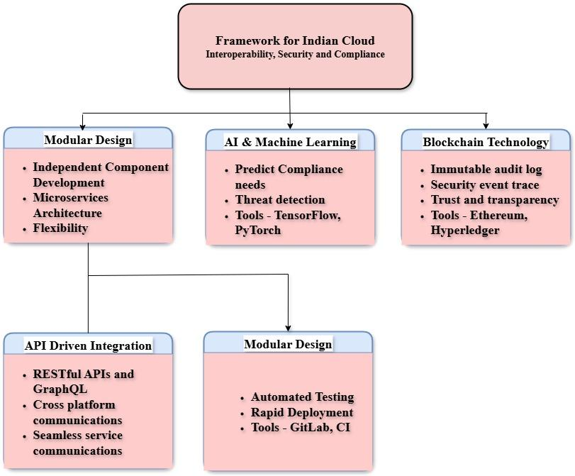
Figure 1: Proposed Cloud Framework incorporating Modular Design, AI/ML, and Blockchain Technology.

The development of clear, actionable guidelines for cloud service providers and regulators will focus on translating the new standards into practical steps that can be easily implemented. These guidelines will cover essential aspects such as best practices for ensuring interoperability, maintaining robust security measures, and adhering to regulatory compliance. The guidelines will include detailed instructions on integrating the standards into existing cloud infrastructures, using tools like RESTful APIs for interoperability and Hyperledger for compliance tracking. Additionally, the guidelines will provide checklists, flowcharts, and templates to streamline the implementation process, ensuring that both cloud service providers and regulators can adopt the new standards efficiently and consistently. The goal is to make these guidelines accessible and straightforward, minimizing the complexity of implementation while maximizing the impact on improving cloud service quality and reliability.
5. IMPLEMENTATION CASE STUDY: TOWARDS A GENERALIZED MIGRATION PLATFORM

5.1 Platform Vision and Baseline Methodology
Current open-source technologies, such as cluster backup utilities (e.g., Velero) and standardized object storage protocols (e.g., S3-compatible endpoints), possess the foundational capabilities to be orchestrated into a unified, provider-agnostic Migration Platform. Such a platform would abstract the complexities of moving stateful and stateless workloads between any managed cloud environment and private infrastructure.To validate the feasibility of this platform model, a baseline proof-of-concept was executed. The implementation migrated workloads from a managed cloud environment (AWS EKS) to a local bare-metal target.The baseline methodology involved:
- Transit Infrastructure: Establishing a cloud-agnostic transit bucket to act as the intermediary storage layer for cluster state and volume snapshots.
- Platform Orchestration: Deploying synchronization agents across both the source cloud and the target bare-metal environment.
- Storage Interoperability Translation: Utilizing local configuration maps to dynamically intercept cloud-specific storage class requests (e.g., cloud block storage) and remap them to the target's standard local storage equivalents.

5.2 Baseline Telemetry and Viability
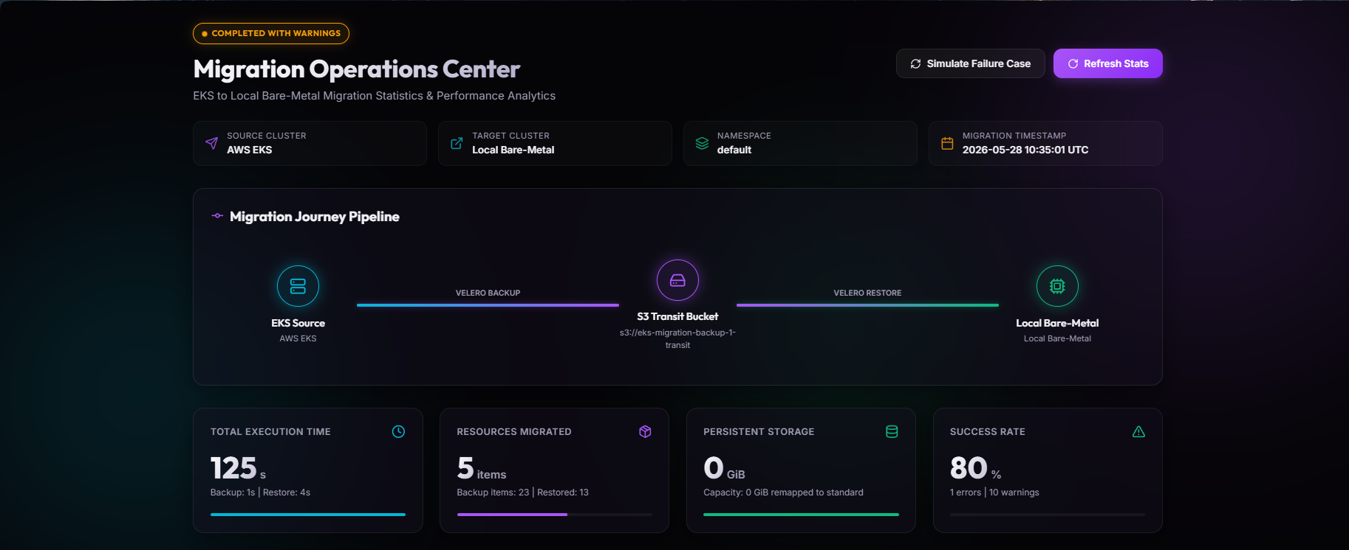
The telemetry from this baseline execution strongly validates the data-plane efficiency of forming a platform from existing technologies. The automated pipeline achieved a total execution time of 125 seconds. The snapshot phase successfully captured 23 cluster resources in 1 second, while the subsequent target restoration phase recreated 13 resources in 4 seconds.Achieving an 80% success rate out-of-the-box, the platform effectively recreated standard Kubernetes primitives, resulting in a target state mirroring the core source architecture (1 Pod, 1 Deployment, 2 Services, and 1 Ingress). This confirms that existing tools are highly capable of handling the raw data and state transfer required for a generalized platform.
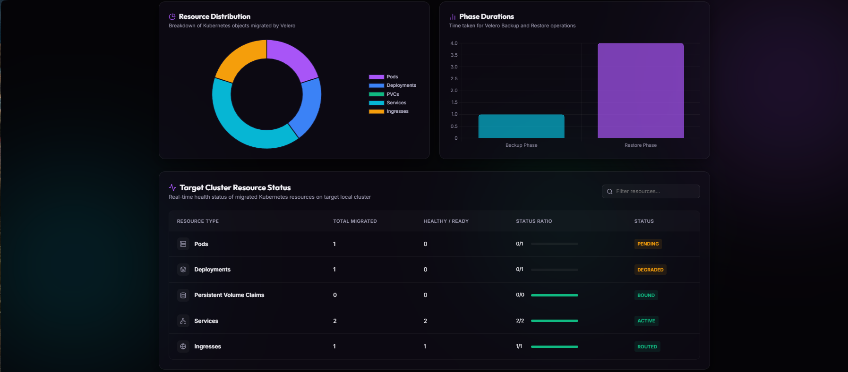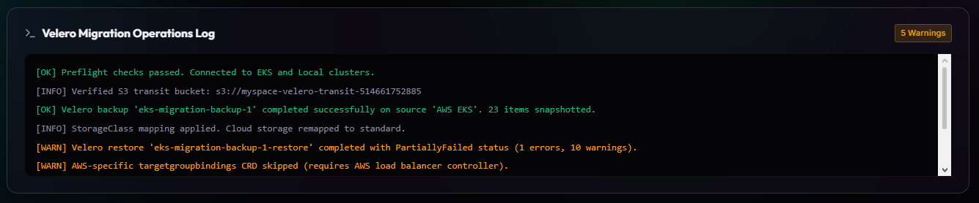

Figure 2: Dynamic Telemetry of Kubernetes Migration Pipeline, highlighting execution time and item count for Backup and Restore phases.

5.3 Platform Limitations and Opportunities for Innovation
While the baseline model successfully migrated the core application, the operation completed with a PartiallyFailed status (1 error, 10 warnings). These warnings illuminate the current limitations of relying purely on existing state-transfer technologies, while also defining the exact development roadmap required to build a truly seamless migration platform:
- Proprietary Infrastructure Abstractions: The baseline platform successfully skipped unsupported proprietary resources, such as cloud-specific load balancer bindings (targetgroupbindings), preventing cluster panic. However, a major opportunity for a future platform is the development of an Abstraction Translation Engine. Instead of merely dropping unsupported Custom Resource Definitions (CRDs), the platform could automatically translate a cloud load balancer request into a bare-metal equivalent, such as an NGINX Ingress controller configuration.
- Identity and Registry Coupling: A restored application pod entered an ImagePullBackOff state due to hardcoded dependencies on a private cloud container registry (e.g., AWS ECR) requiring proprietary IAM authentication. This presents a prime opportunity to build an Automated Asset Localization Pipeline into the platform. A fully realized platform would detect private registry dependencies during the preflight phase, automatically pull the images using source credentials, and seamlessly side-load them into the target cluster's local registry (or inject newly minted ImagePullSecrets into the manifest) without user intervention.
6. CONCLUSION
The development of a generalized, provider-agnostic migration platform is highly viable using today's open-source technologies. As demonstrated by the baseline implementation, the mechanics of state transfer and storage remapping are swift and reliable. By acknowledging current technical drawbacks—such as proprietary load balancers and coupled registry identities—as clear opportunities for automated translation layers, the industry can confidently move toward an ecosystem defined by true cloud portability and operational freedom.
7. REFERENCES
[1] Deshmukh, R., Jadhav, B., Barnabas, V, Adhav, S. (2024). E-Governance and igital Innovation—Indian Perspective. In International Conference on Smart Computing and Communication (pp. 199-212). Singapore: Springer Nature Singapore.
[2] Zehra, F., Khan, F. S., Mazhar, S. S., Khan, A. S. (2024). Revisiting Digital India 2.0: Exploring New Horizon and Insights. In New Innovations in AI, Aviation, and Air Traffic Technology (pp. 292-317). IGI Global.
[3] Sharma, M., Gupta, R., Acharya, P., Jain, K. (2023). Systems approach to cloud computing adoption in an emerging economy. International Journal of Emerging Markets, 18(9), 3283- 3308.
[4] Shetty, J. P. Panda, R. (2023). Cloud adoption in Indian SMEs–an empirical analysis. Benchmarking: An International Journal, 30(4), 1345-1366.
[5] Olaya, Paula, Jakob Luettgau, Camila Roa, Ricardo Llamas, Rodrigo Vargas, Sophia Wen, I-Hsin Chung, Seetharami R. Seelam, Yoonho Park, Jay F. Lofstead, and Michela Taufer. (2023). "Enabling Scalability in the Cloud for Scientific Workflows: An Earth Science Use Case." 2023 IEEE 16th International Conference on Cloud Computing (CLOUD). https://dx.doi.org/10.1109/CLOUD60044.2023.00052.
[6] Wang, Qinglong, Runzhe Wang, Yuxi Hu, Xiaohai Shi, Zheng Liu, Tao Ma, H. Song, and Heyuan Shi. 2023. "KeenTune: Automated Tuning Tool for Cloud Application Performance Testing and Optimization." Proceedings of the (2023) ACM/SPEC International Conference on Performance Engineering. https://dx.doi.org/10.1145/3597926.3604920.
[7] Thavappiragasam, M., W. Elwasif, and A. Sedova. (2022). "Portability for GPU-accelerated molecular docking applications for cloud and HPC: can portable compiler directives provide performance across all platforms?" arXiv preprint arXiv:2203.02096. https://dx.doi.org/10.48550/arXiv.2203.02096.
[8] Hiremath, Tej. C., and Rekha K. S. (2022). "Optimization enabled deep learning method in container-based architecture of hybrid cloud for portability and interoperability-based application migration.".
[9] Rodrigues, P., Filipe Freitas, and José Simão. (2022). "QuickFaaS: Providing Portability and Interoperability Between FaaS Platforms.".
[10] Shastri, Arunima, and Bhupinder Singh. (2022) "Demystifying Data Justice: Legal Response to India’s Privacy and Security Standards: Challenges in Cloud Computing.".
[11] Ramalingam, Chithambaramani, and Prakash Mohan. (2021) "Addressing Semantics Standards for Cloud Portability and Interoperability in Multi Cloud Environment." Symmetry 13, no. 2: 317. https://dx.doi.org/10.3390/sym13020317.
[12] Akhtar, S., Abdul Rauf, Haider Abbas, and M. F. Amjad. (2020) "Inter Cloud Interoperability Use Cases and Gaps in Corresponding Standards." 2020 IEEE International Conference on Dependable, Autonomic and Secure Computing, https://dx.doi.org/10.1109/DASC-PICom-CBDCom-CyberSciTech49142.2020.00103.
[13] Bouzerzour, Nour El Houda, Souad Ghazouani, and Y. Slimani. (2020). "Cloud interoperability based on a generic cloud service description: Mapping OWL-S to GCSD." 2020 IEEE 29th International Conference on Enabling Technologies: Infrastructure for Collaborative Enterprises (WETICE). https://dx.doi.org/10.1109/WETICE49692.2020.00022.
[14] Jong, F. D., B. Maegaard, Darja Fišer, D. V. Uytvanck, and A. Witt. (2020). "Interoperability in an Infrastructure Enabling Multidisciplinary Research: The case of CLARIN." Proceedings of the 12th Language Resources and Evaluation Conference. https://www.aclweb.org/anthology/2020.lrec-1.417.
[15] Androutsopoulou, Maro, John Violos, D. Askounis, T. Varvarigou, Panagiotis Kokkinakos, and C. Kontzinos. (2020). "The European Code Of Conduct On Cloud Services And Data Portability: What Changes In The Cloud Ecosystem.".
[16] Chouhan, S. (2019). GI Cloud-MEGHRAJ-key pillar of e-governance system in India. Adv.Innov. Res, 6(1), 348-352.
[17] Leppänen, T., Claudio Savaglio, Lauri Lovén, W. Russo, G. D. Fatta, J. Riekki, and G. Fortino. (2018) "Developing Agent-Based Smart Objects for IoT Edge Computing: Mobile Crowdsensing Use Case." Internet and Distributed Computing Systems. https://dx.doi.org/10.1007/978-3-030-02738-4_20.
[18] Sitaram, D., Sudheendra Harwalkar, Chetna Sureka, Harsh Garg, Manusarvathra Dinesh, M. Kejriwal, Shikhar Gupta, and V. Kapoor. (2018) "Orchestration Based Hybrid or Multi Clouds and Interoperability Standardization.".
[19] Sony, Ivin Polo. (2015) "Inter-Cloud application migration and portability using Linux containers for better resource provisioning and interoperability."

